Software Engineering CS301

Web Application for NIC

Coding Metrics

Ronald Tony (U101116FCS103)

Sabyasachi Mishra (U101116FCS104)

Saloni Jain (U101116FCS107)

Shubhangi (U101116FCS127)

Sourav Upadhya (U101116FCS134)

Sourish Das (U101116FCS135)

**1. Introduction**

This document will provide the coding metric values for the project. The metric tools used for the same are,

* SDMetrics – the Object-Oriented design quality measurement tool for the UML™. SDMetrics analyzes the structure of your UML models.
* PHPloc – A tool for quickly measuring the size and analyzing the structure of a PHP project.

**2. SDMetrics Output**

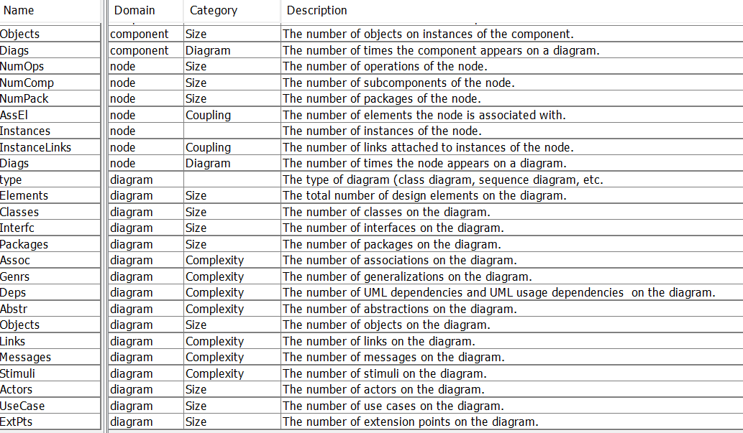This section shows the analysis of UML metrics for the whole project. The UML files used are the state diagrams from the Software Design Specifications. Below are the metric analyses provided by the tool.

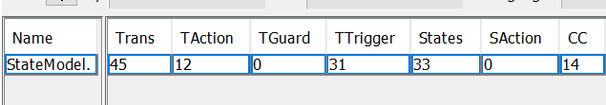Overall Analysis

Below are the details of individual metrics

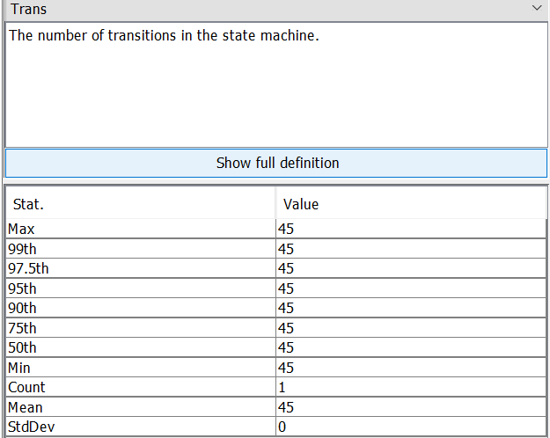

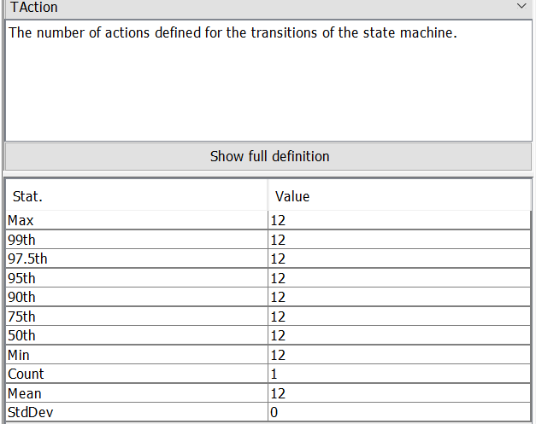

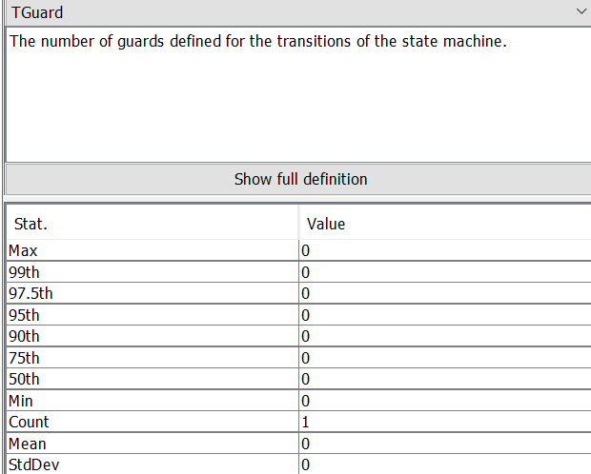

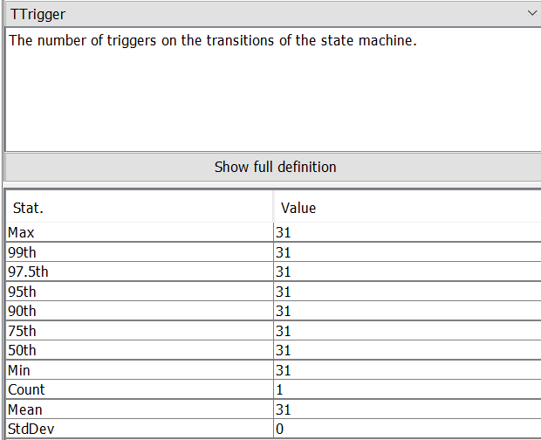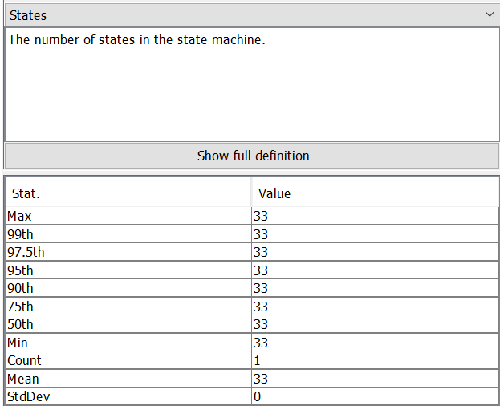

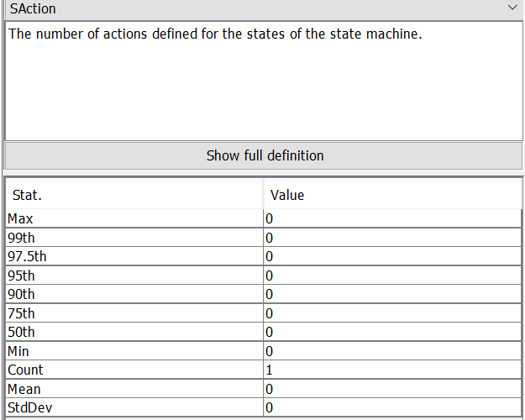

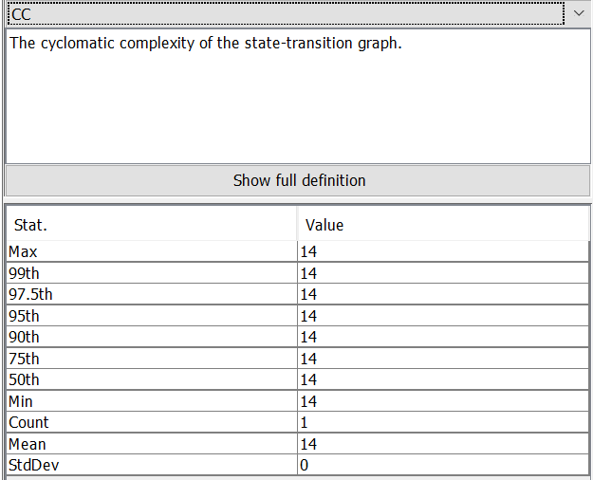

**2. PHPloc Output**

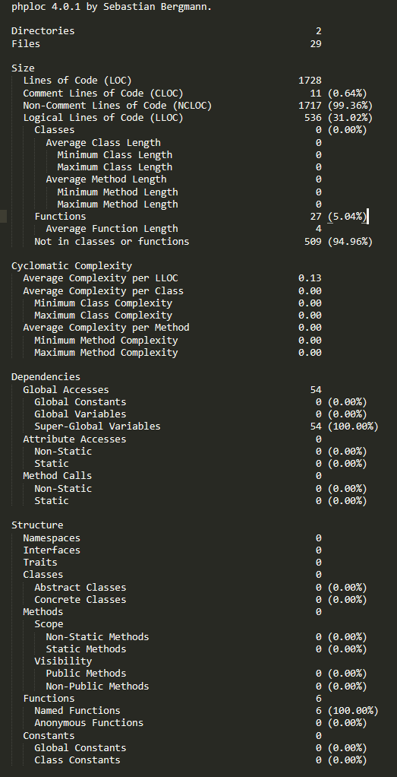This section shows the analysis of code metrics for the whole project (Client - Side and Admin - Side).